GUIDLINE FOR CREATE THE EXPENSE
- EXPENDITUTE AUTHORIZATION FLOW
  - Register Expenditure
User: Isabelita.marques
At main screen
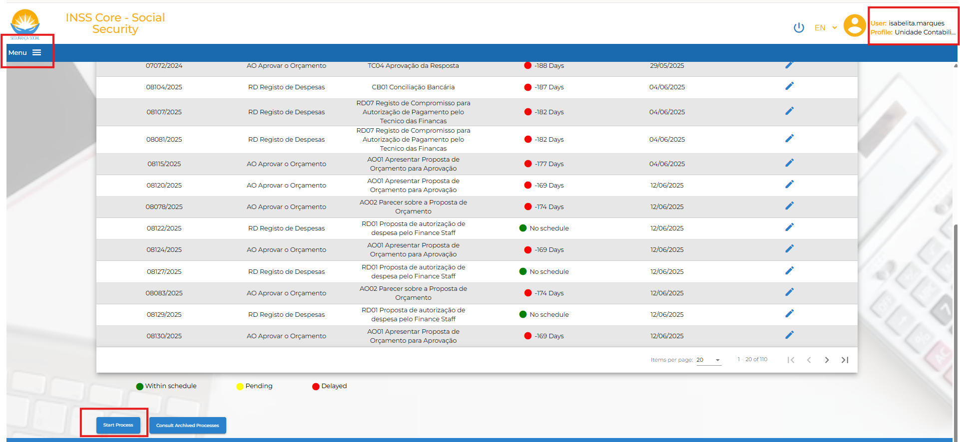
Click the button Start Procee to propose the expenditure. Choose the options to register the expenditue.
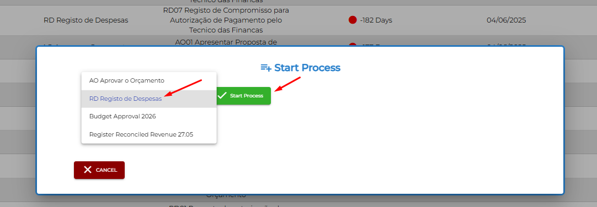

Get the resut:
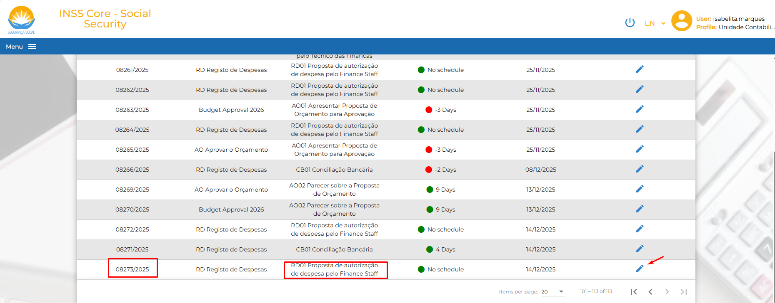
Fulfill all the cells to register the budget and upload documents related.
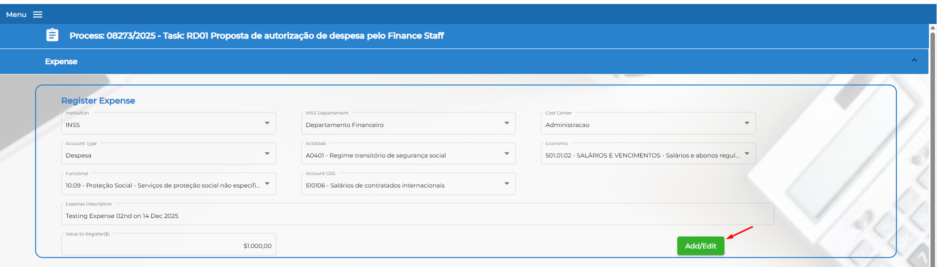
Note: Click to the button Add/Edit to record expense on the system. The system shall show the screen:
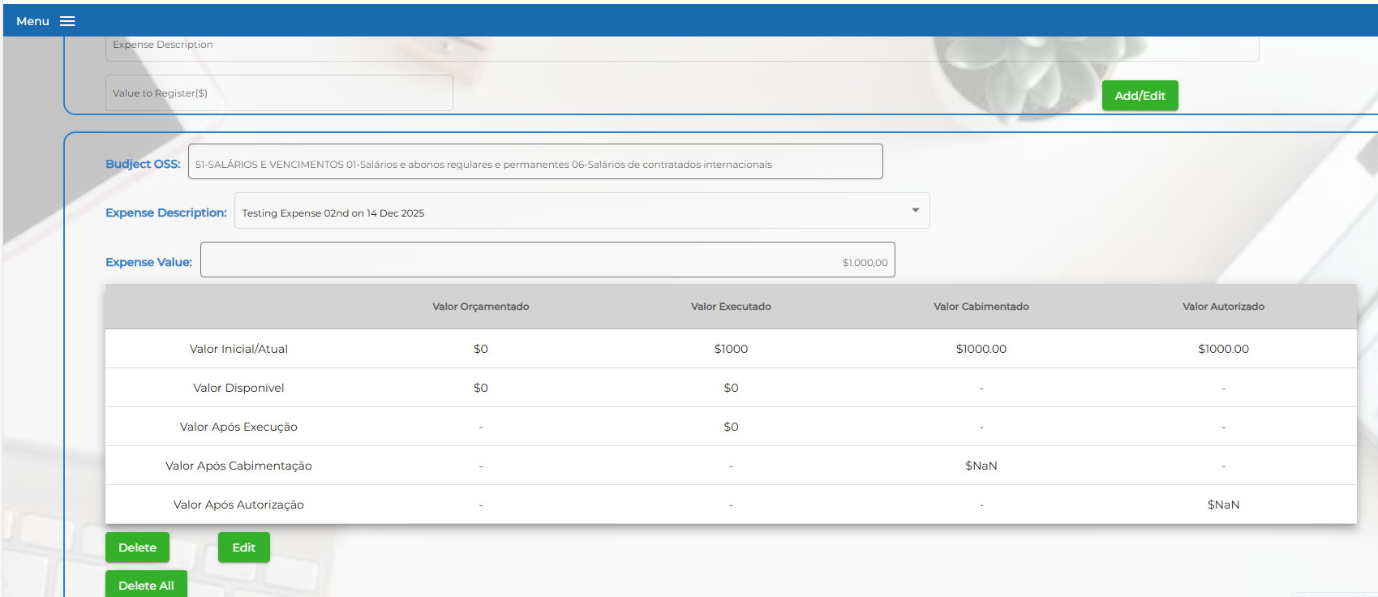
The upload the document related for the expense, click the button “ Insert file”
At the Task Action, choose the option and click “ save” button
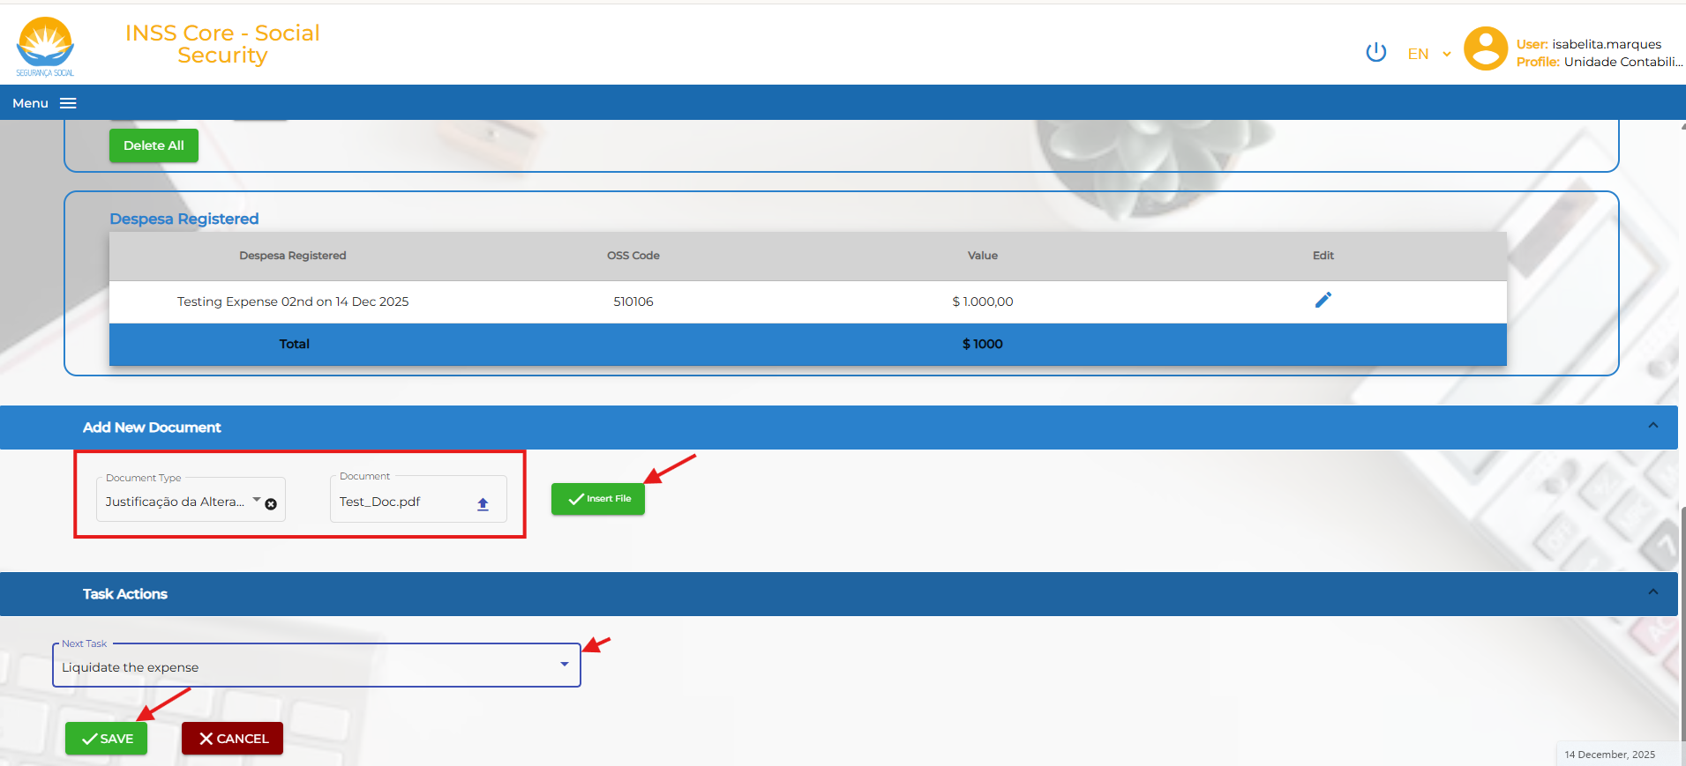
Note: only expenses with associated accounts have been registered in the budget registration process shall be recorded at this step.
In the guideline, for testing expenditure flow:
- Institution: INSS
- INSS Departament: Financal
- Cost center: Administrator
- Account type: Expense
- Actidade: A04 - Regime Contributivo de Repartição
- Economic: 501.01.02 - SALÁRIOS E VENCIMENTOS
- Funcional: 10.09 Protecc Social
- Account Oss: 510106 – Salary
- Expense Description: Testing Expense on 14 12 2025
- Value to register: 10.000,00 USD
In fact, base on the real expense, cost center, Actidade, Economic and Funcional, Acount Oss shall be different.
  - Review Expenditure
Account: Agus.berek
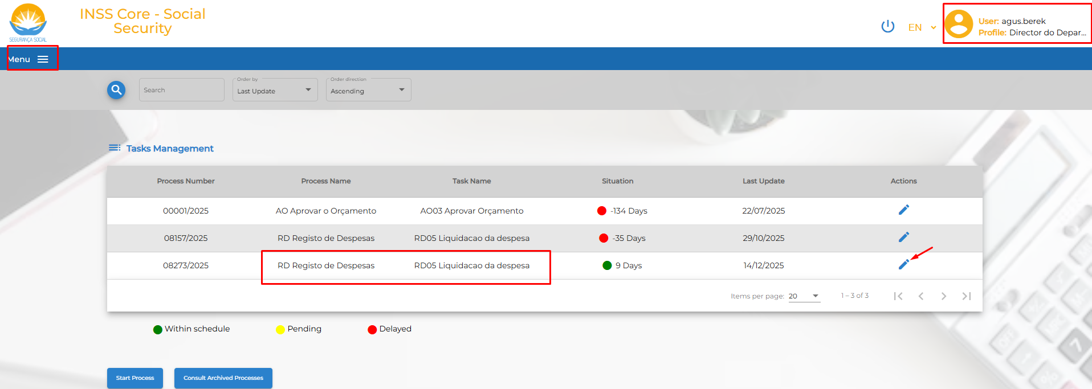
Click the button to review the registed expense to decide:
Incase: Rejected, choose” Recitify the expense registration”
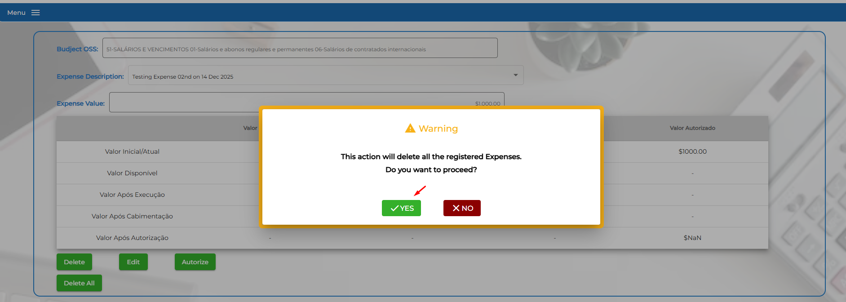
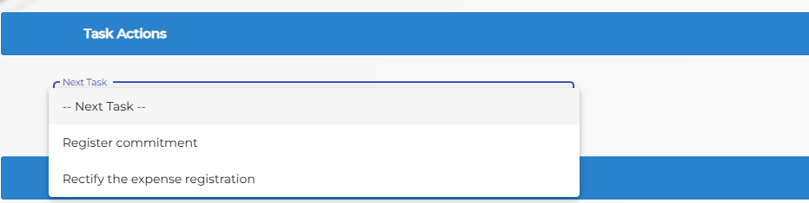
Incase: Approve the expense registed, Click button “ Autorize” and then click “Cabimentar”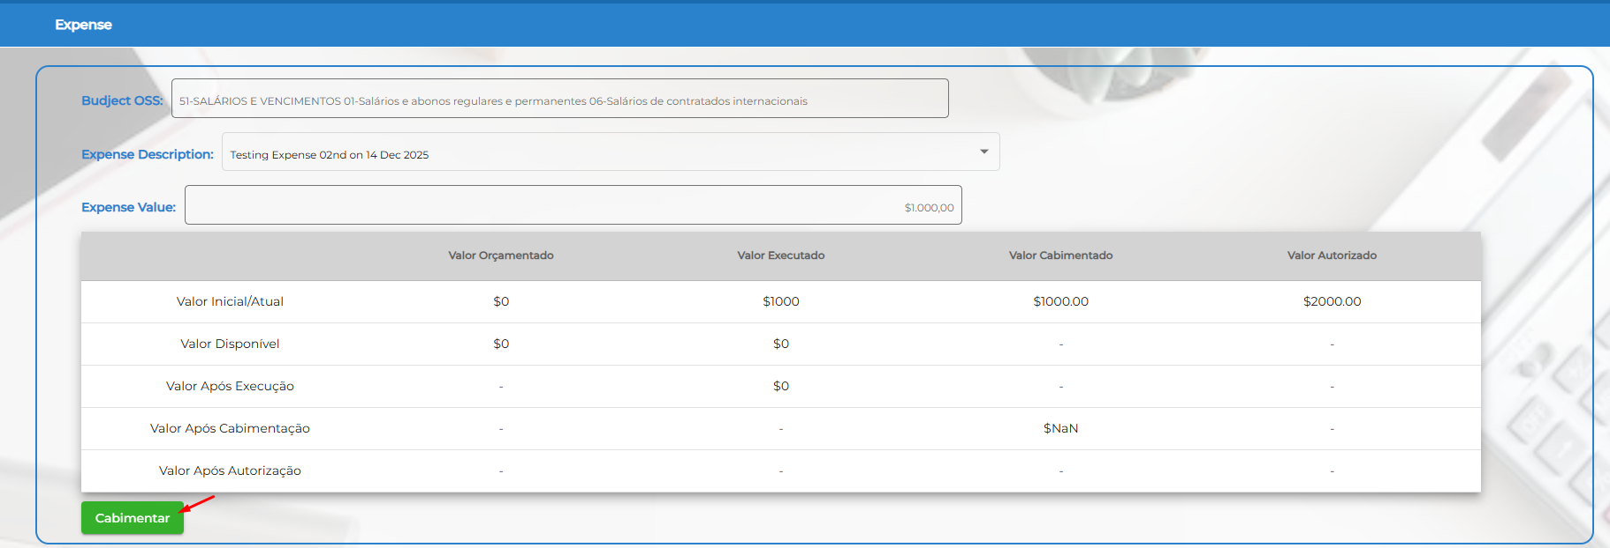
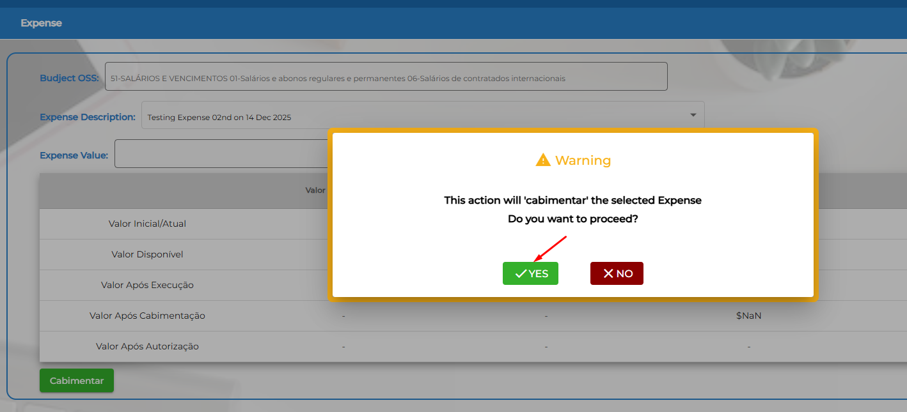
And then, move to next step and save to finish this step.
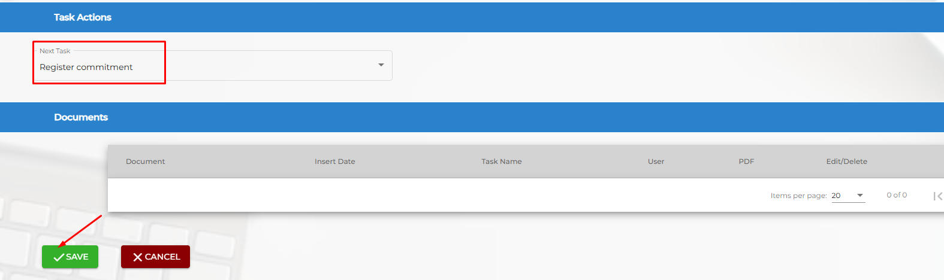
1.3 Registo de Compromisso para Autorização de Pagamento pelo Tecnico das Financas
User: Isabelita.marques
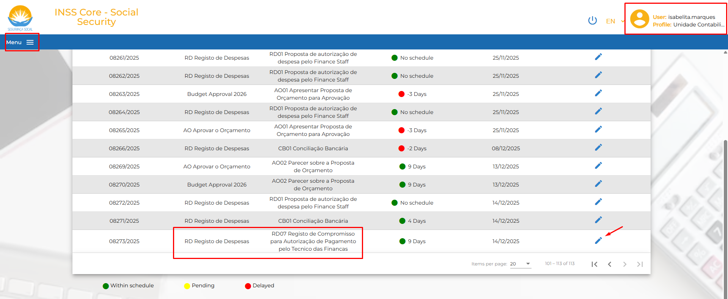
Choose the classification of the expense
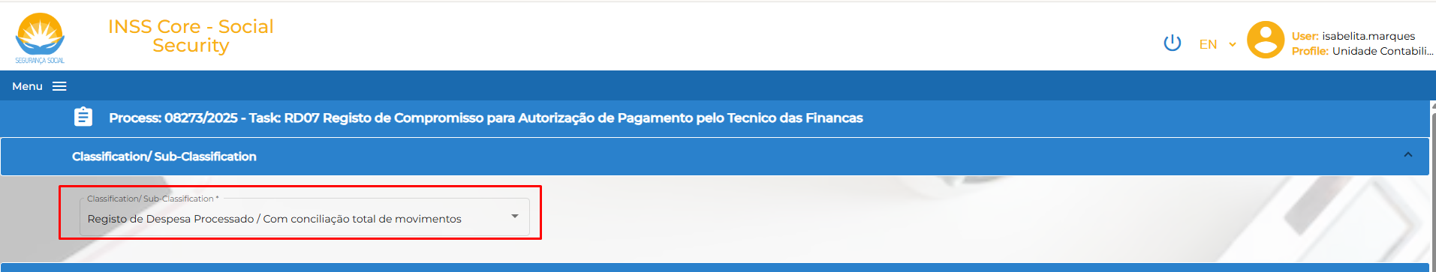
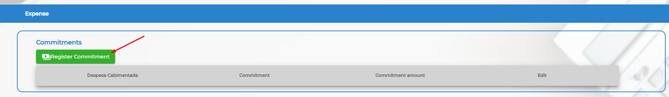
Fulfill all the task on the system
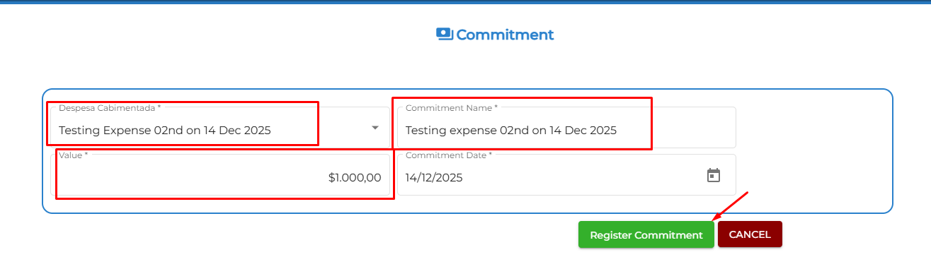
Then Execute the payment”
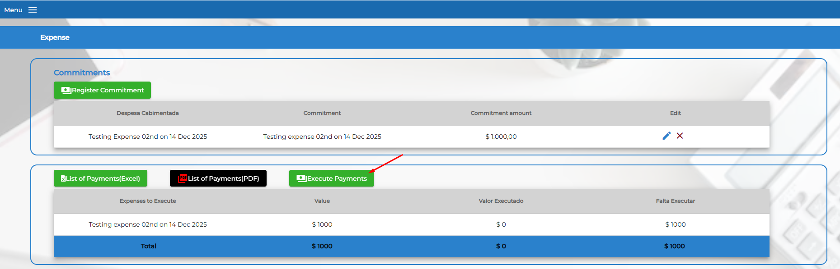
Finance executive complete the “ Execute payment” form
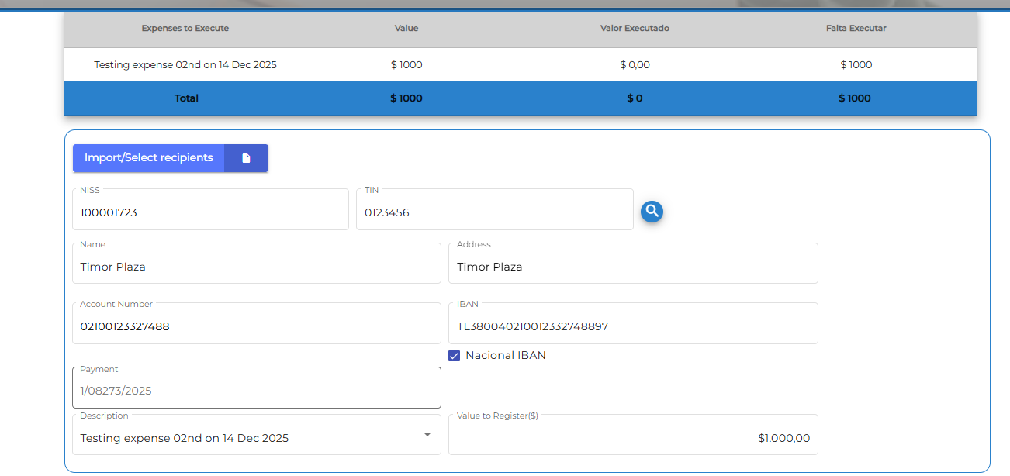
Test data:
NISS: 1000001723
TIN: 0123456
Bank acc: 02100123327488
Iban: TL380040210012332748897
Swift: BNCTTLDD
- User doing the manual entry for the expenditure transaction
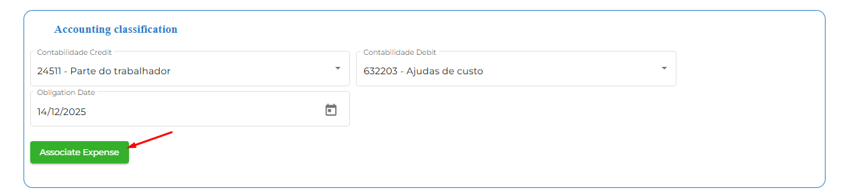
Then click button” Terminar”
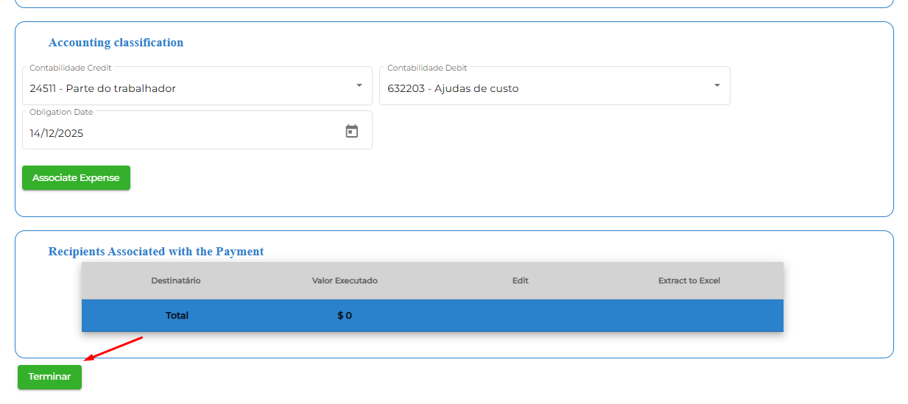
- User upload all related document for payment process ( Authorization of payment”
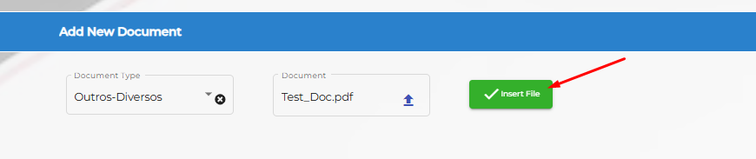
Click Insert file to upload document into the system.
At “ Task actions”, choose next task and save the transtion.

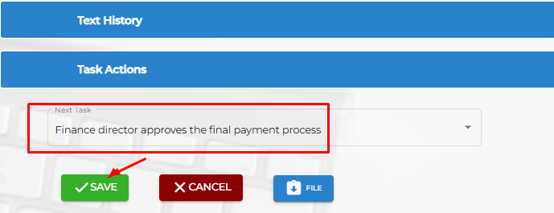
  - The Finance director validates the payment documents “Autorizacao de pagamento pela Directora Finance”
User: agus.berek
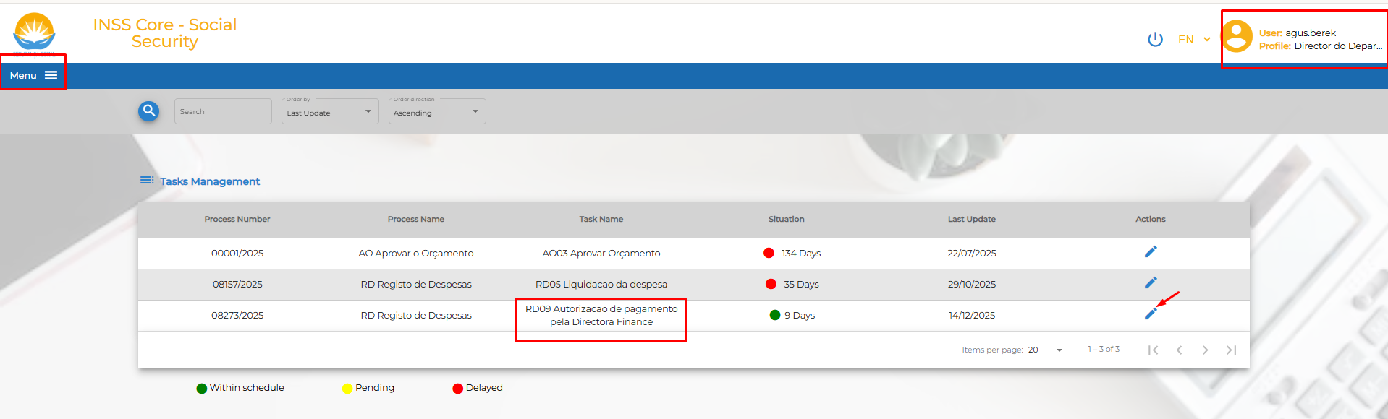
Veiw the list attached document”
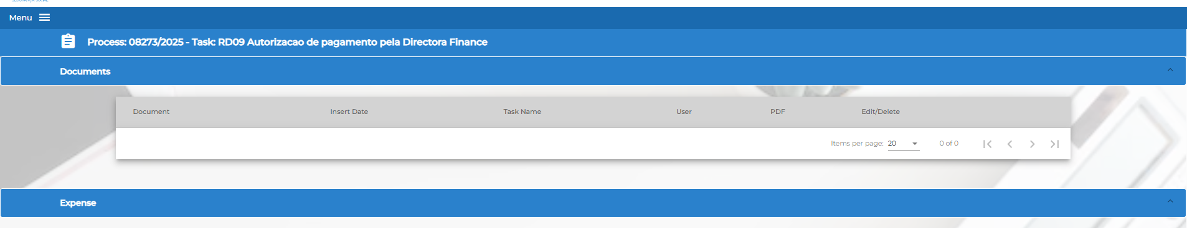
Issue: Payment order”
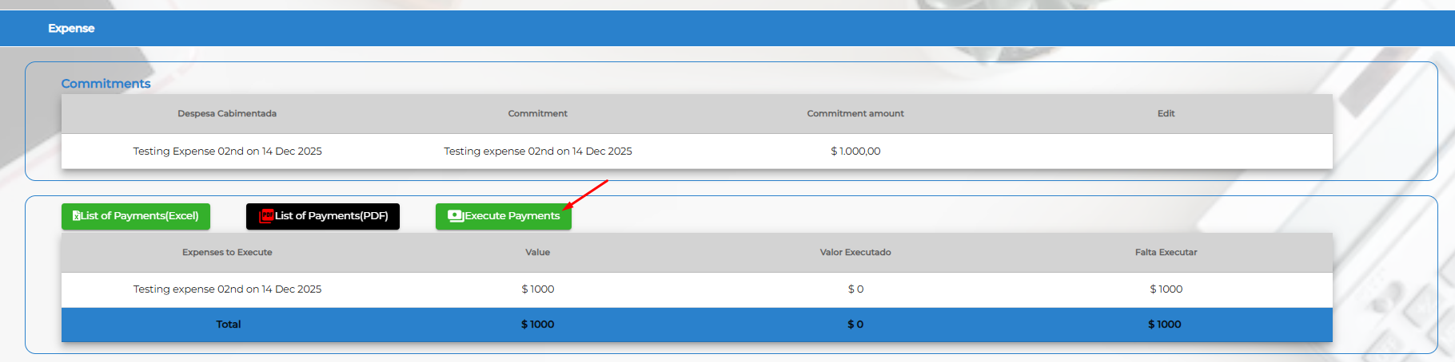
Fulfill all the informtion as the system request
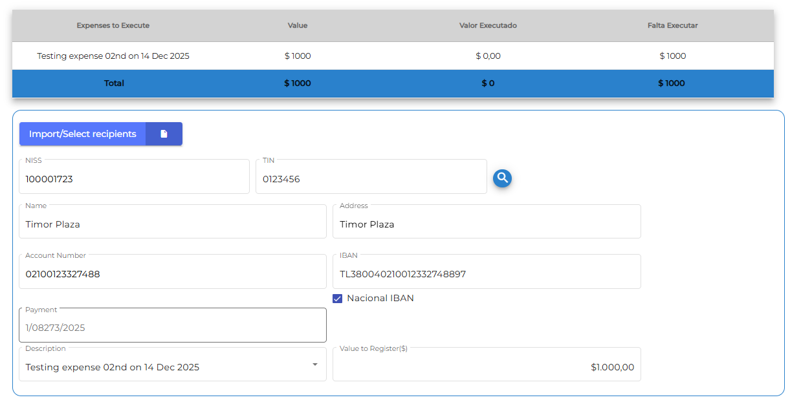
Fulfil the Accounting transaction. Base on the real expense, accounting number shall be different.
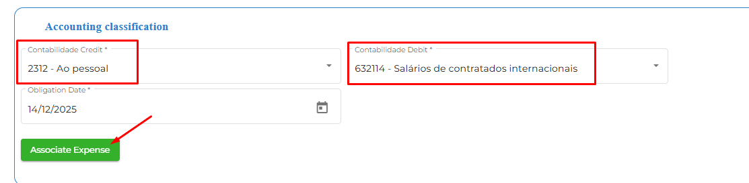
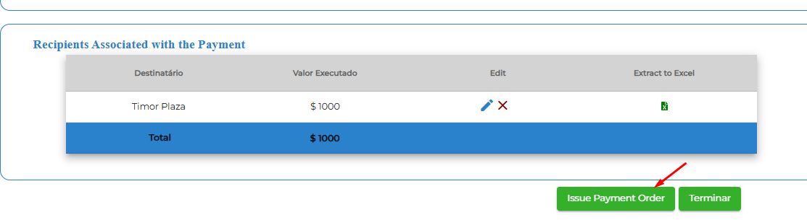
The system automatic issue the payment form 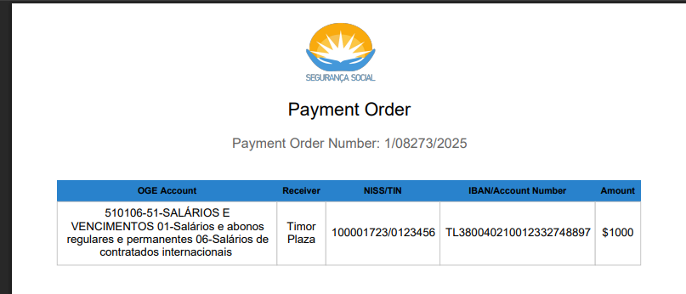
Take the next step
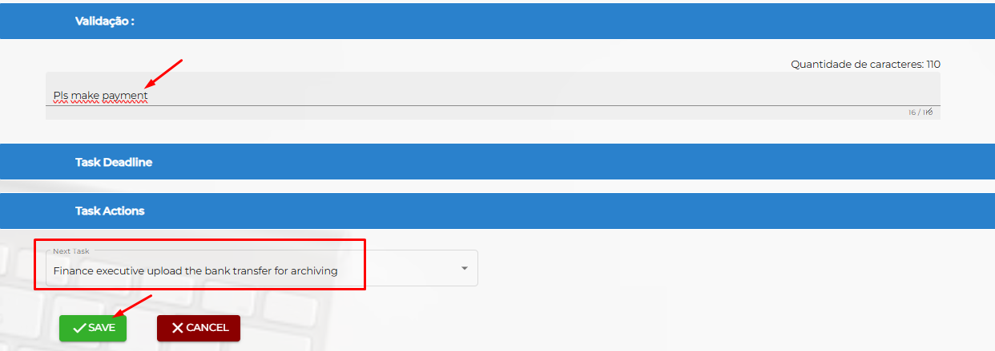
Finish this step.
  - Finance executive uploads the bank transfer proof

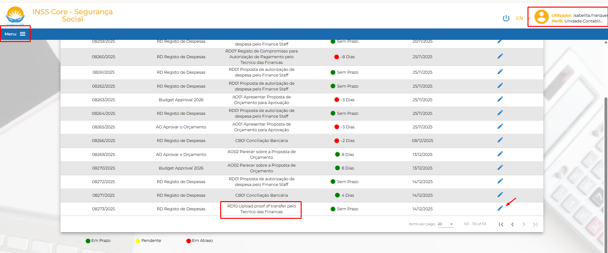
Upload bank transfer and save transtion
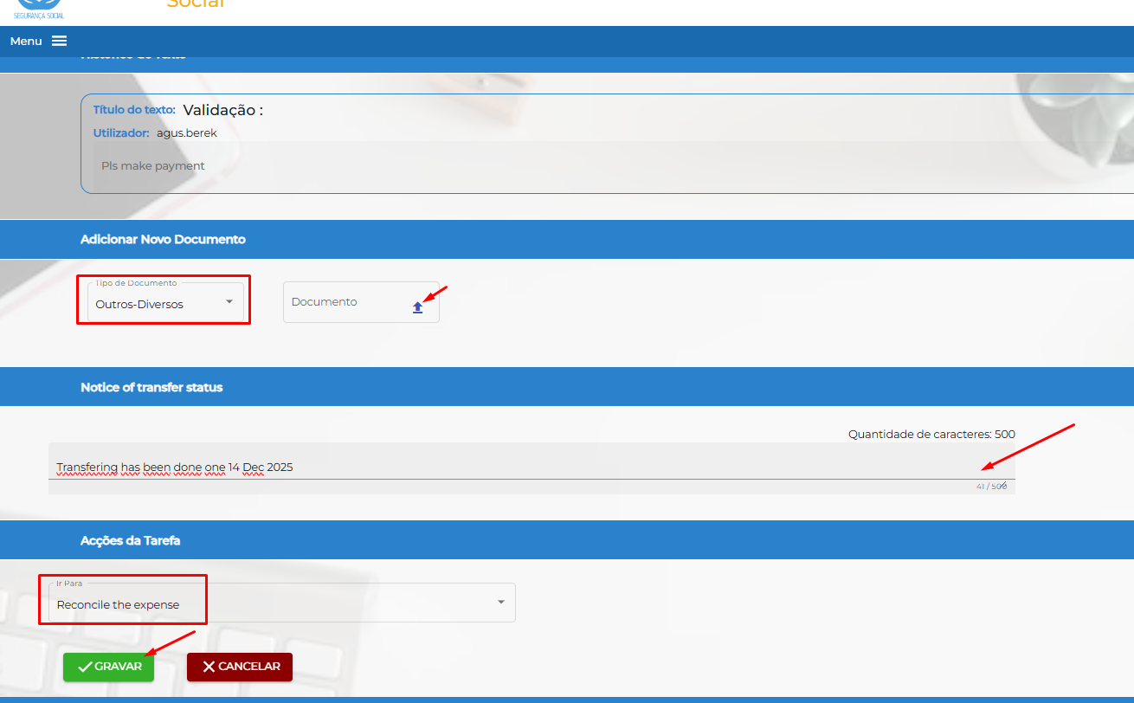
  - Conciliation Accounting transaction CB01 Conciliação Bancária
User: isabelita.marque
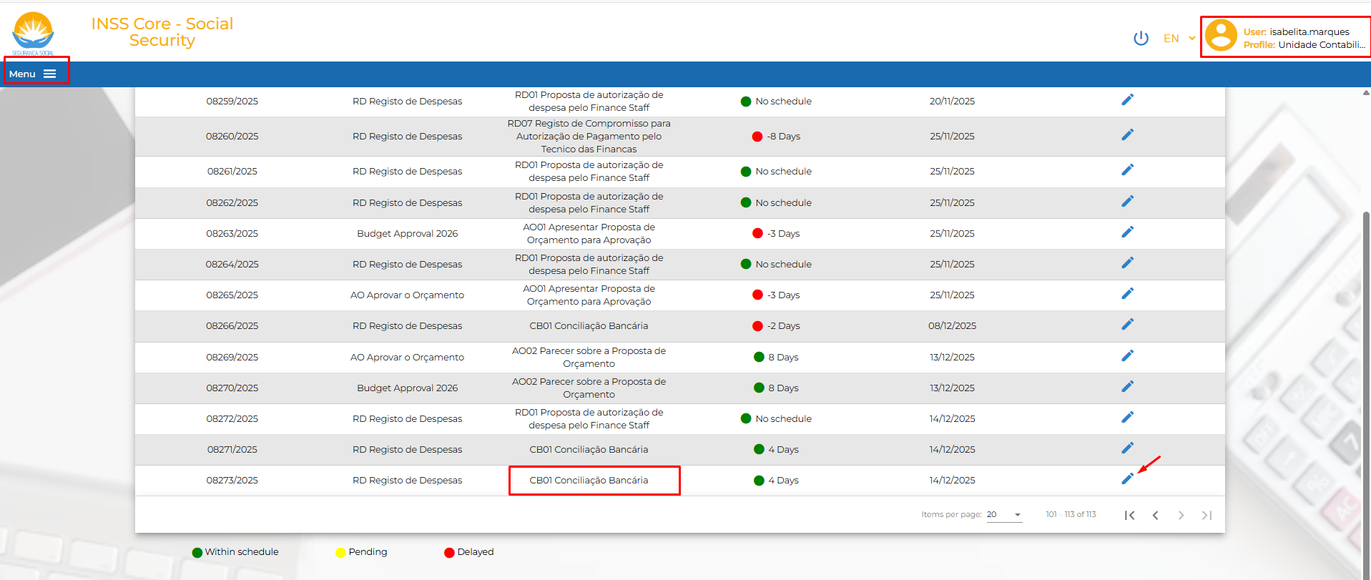
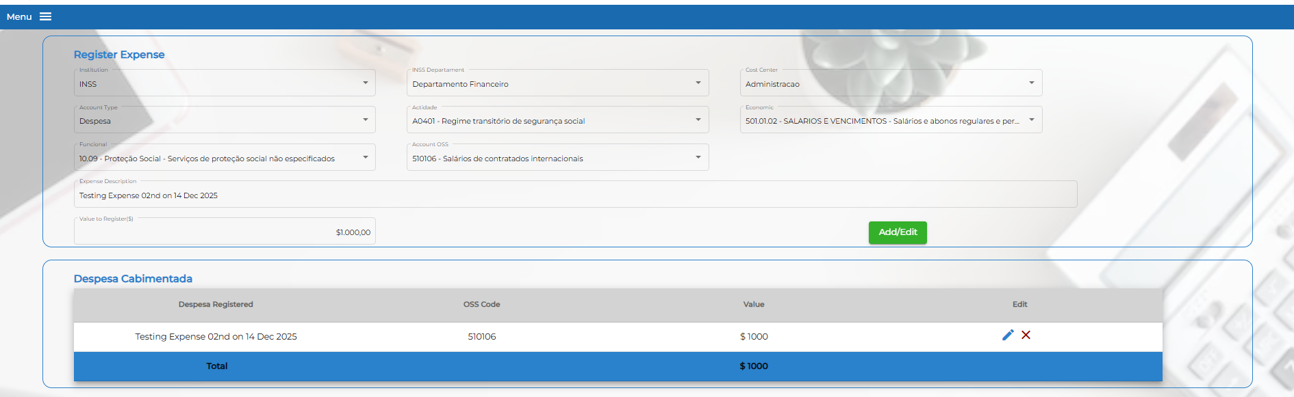

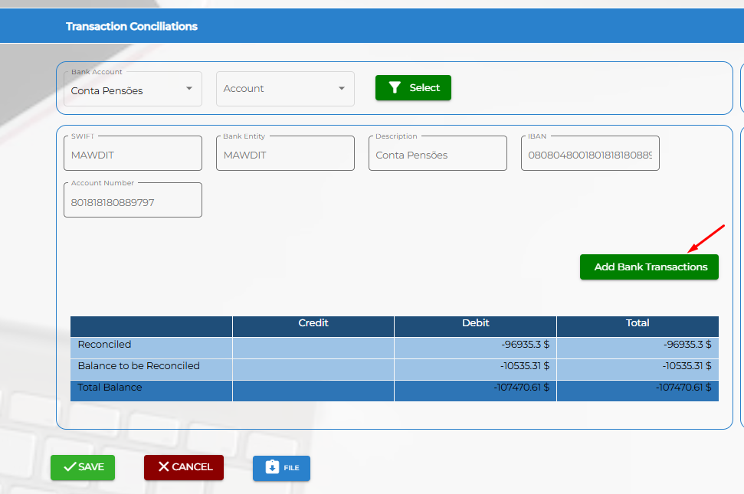
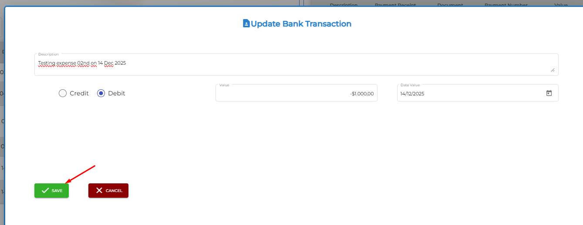
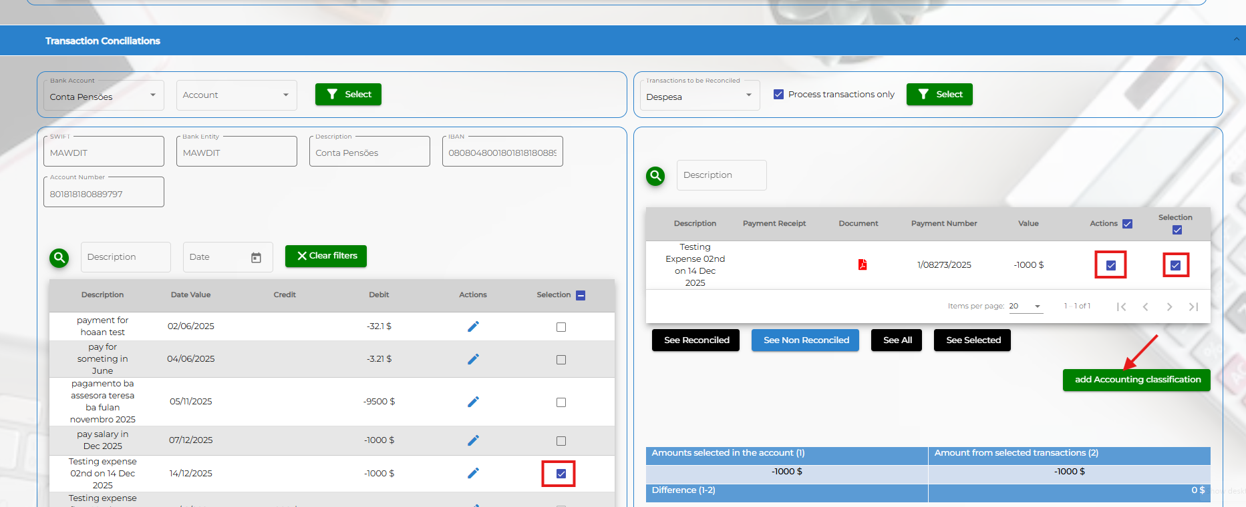
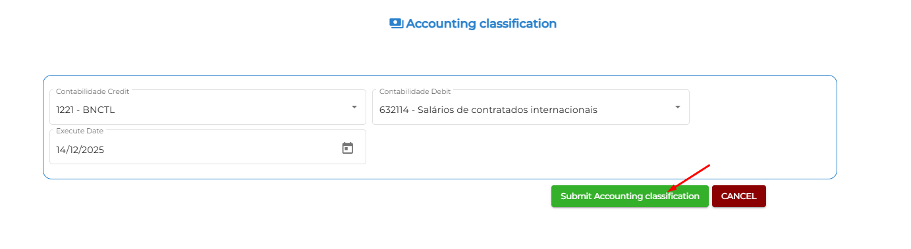
Then Finance executive concilate the accounting transaction
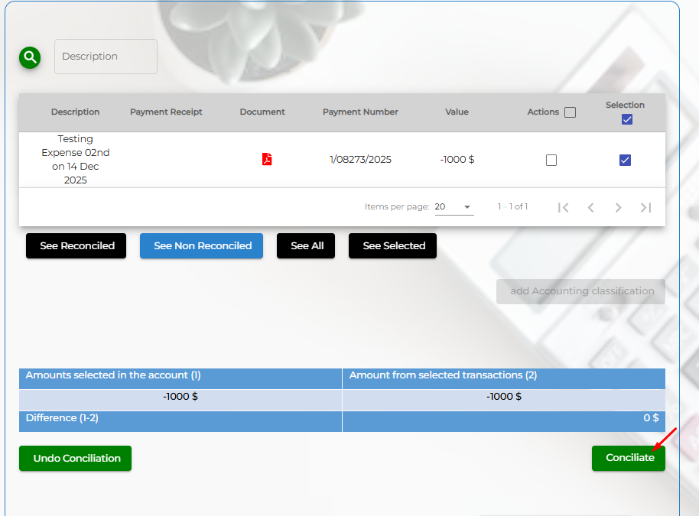
And confirm the action to move next step
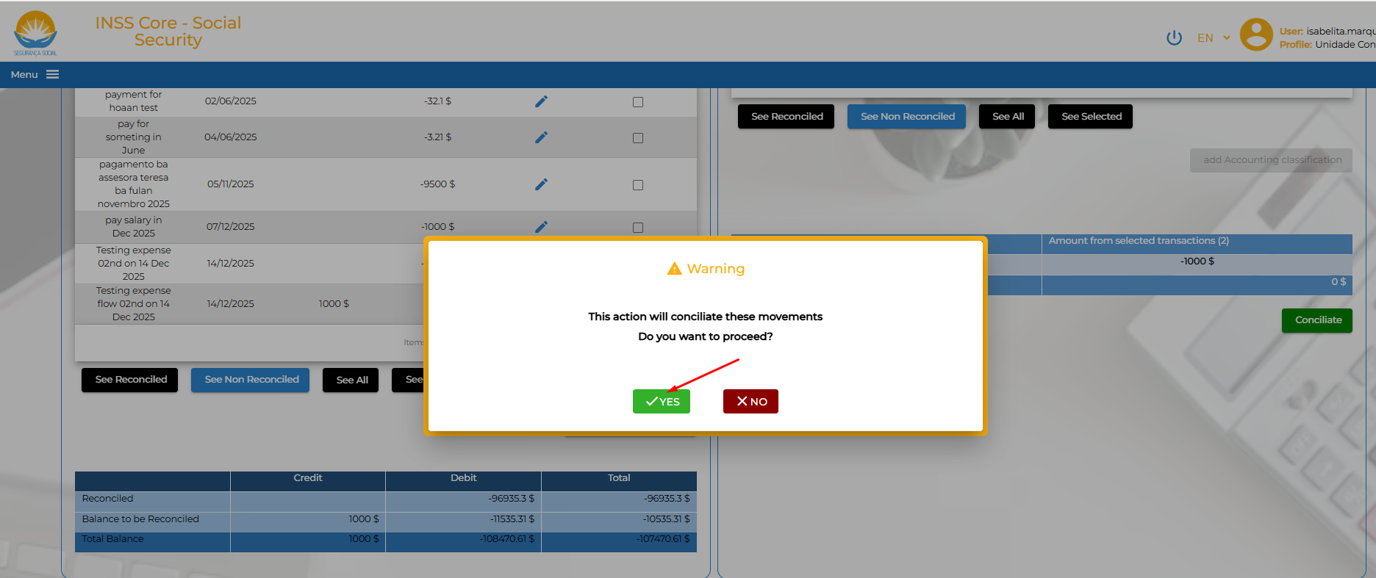
Click the button “File” to finish task and back to main screen